April 2, 2012
Lecture 20
Group 14
Jakub Jarnik
Rishad Khan
Patrick White

Direct Band Gap

The band gap represents the minimum energy difference between the top of the valence band (VB) and the bottom of the conduction band (CB). In a direct band gap semiconductor, the top of the valence band and the bottom of the conduction band occur at the same value of momentum, as shown in Figure 1 below.

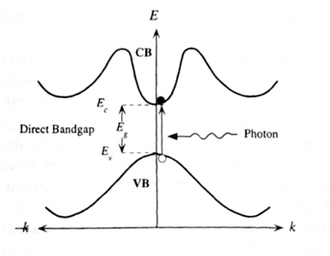
Figure 1: Direct Band Gap material (energy VS momentum)

Whenever an electron acquires energy sufficient to jump from the valence band (VB) to the conduction band (CB) a free hole is created in the valence band, and hence, electron-hole pair is generated as shown in Figure 6.

An electron falling from the conduction band (CB) to an empty state in the valence band (VB) is called recombination. When an electron and hole recombine, an electron-hole pair is annihilated.

A photon of energy E_{g}, where E_{g} is the band gap, can produce an electron-hole pair in a direct band gap semiconductor quite easily, because the electron does not need to be given momentum. Therefore, a photon carrying energy equivalent to E_{g} can create an electron-hole pair. Similarly, a photon (hv) is emitted when recombination occurs. Therefore, just two entities are required: electron and holes.

Uses – LEDS, LASERS, DETECTORS, high-speed power amps. Good absorbers.

Examples – GaAs, InN, GaN, InP, GaP

Indirect Band Gap

In an indirect band gap semiconductor, the maximum energy of the valence band occurs at a different value of momentum to the minimum in the conduction band energy as shown in Figure 2 below:

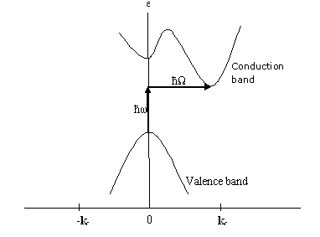
Figure 2: Indirect Band Gap material (energy VS momentum)

An electron must undergo a significant change in its momentum for a photon of energy E_{g} to produce an electron-hole pair in an indirect band gap semiconductor. This is possible, but it requires such an electron to interact not only with the photon to gain energy, but also with a lattice vibration (phonon) in order to either gain or lose momentum. In Figure 2, the photon is shown by hw while hΩ is the phonon.

The indirect process proceeds at a much slower rate, as it requires three entities to intersect in order to proceed: an electron, a photon and a phonon as compared to direct band gaps (electron and hole required only). This is analogous to chemical reactions, where, in a particular reaction step, a reaction between two molecules will proceed at a much greater rate than a process that involves three molecules.

The same principle applies to recombination of electrons and holes to produce photons. The recombination process is much more efficient for a direct band gap semiconductor than for an indirect band gap semiconductor, where the process must be accompanied by a phonon.

As a result of such considerations, gallium arsenide and other direct band gap semiconductors are used to make optical devices such as LEDs and semiconductor lasers, whereas silicon, which is an indirect band gap semiconductor, is not.
Examples – Si, Ge. Si is very popular for low cost and logic devices.

Lasers

Requirements:

1.) Inverted Population
When many e- are at a high E and many h+ at a low E, the population is said to be inverted.
In figure 3 (below), we see an example of an inverted population. By exciting the atom with energy (hv), we push it into the excited state, E2. Then, the atom drops from this state back down to E1 and in the process, emits energy equal to hv.
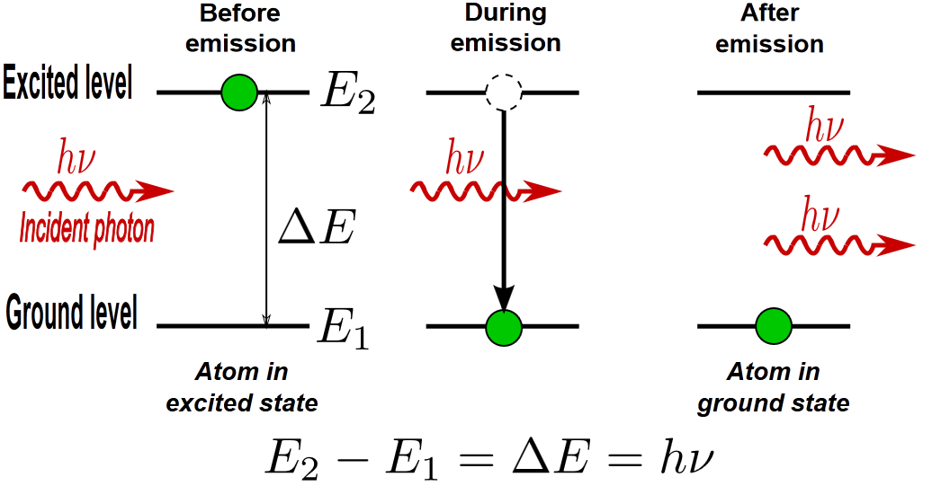
Note: these are not energy bands, they are discrete energy levels.
To do this, we cannot just heat material as that will bring electrons to both bottom and top level. Instead, we use a multilevel energy system as described below (figure 4):
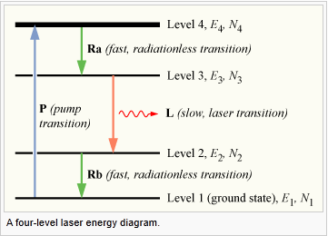
As before, we excite the atom with energy to pop it into the E4 energy level. Then, the atom decays in a fast radiationless transition to energy level E3. As population accumulates in E3, eventually we experience spontaneous or stimulated emission to drop down to energy level E2. Finally, from E2 to E1, we experience a fast radiationless transition again to be brought back to the lowest energy level, E1.
E1 < E2 < E3 < E4
Since the transition from E4 to E3 is rapid, E4 essentially has a population equivalent to 0 (gets depleted quickly). Equivalently, the transition from E2 to E1 is rapid and thus E2 has a population equivalent to 0). Therefore, the transition from E3 to E2 will represent the overall time taken for all transitions.
Laser operation will function at a frequency of the transition from 3 to 2. That is, E3 – E2 = hv₃₂ and v₃₂ = frequency of operation.

2.) Resonant Cavity
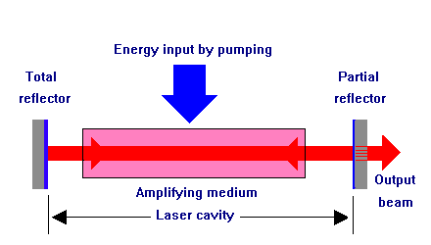
The light emitting material (amplifying/gain medium) is placed inside a resonant cavity formed by mirrors that create a standing wave resonator (shown at left, figure 5). When stimulated by energy, the material will produce light through an inverted population. Light inside the cavity will reflect multiple times creating standing waves at certain frequencies. Since the mirror on one end is not entirely reflective, some of these standing waves will escape and produce light of the frequency of resonance inside the cavity. Very little attenuation is observed.

The Simplest Semiconductor Laser
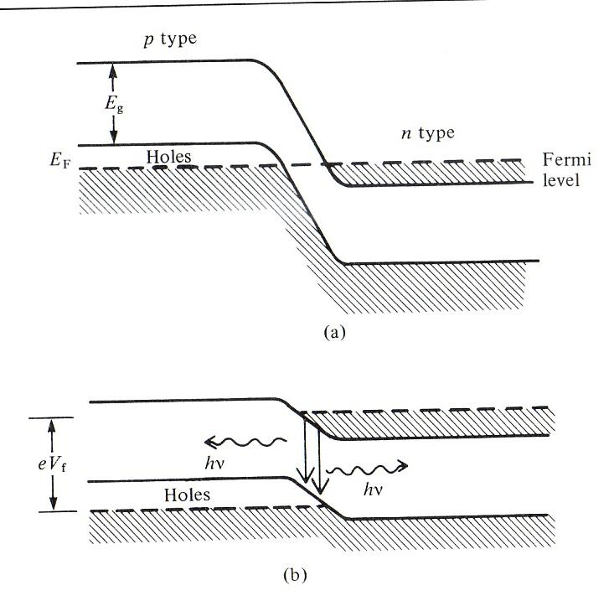
Figure 6 (left) shows the band gap of the simplest semiconductor laser. A P-N junction normally has a depletion region (a gap between electrons and holes that is devoid of charge carriers). By increasing the amount of doping and introducting forward bias, we can reduce the size of this region until electrons and holes overlap, so they can recombine and emit light. Note that this is an inefficient design, and that light is emitted in all directions.

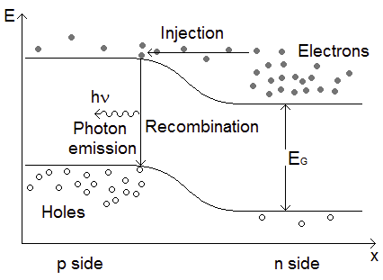

LEDs
Figure 7 (left): Electrons are injected to the p-side where they recombine with holes, emitting light. Conversely, holes migrate to the n-side to recombine with electrons, also emitting light.

Magnets

Mandatory Condition: Unpaired spins

Using the p-orbitals as an example: all orbitals are first filled up with electrons of the same spin as shown in figure 8 below. Only after all orbitals are filled with electrons spins in the same direction do the opposite spin start to be filled and eventually gets completely filled as shown in figure 9 below.

Figure 8: Half filled P- orbitals Figure 9: Filled p-orbitals

Since unpaired spins are required for a material to have magnetic properties, elements which have a larger number of orbitals can potentially demonstrate higher magnetism. Therefore, transition metals are generally good magnetic materials since they have d (5 orbitals). The best magnetic materials are those with the most half-filled orbitals.
Figure 10: Periodic Table with transition metals shown in turquoise ()
In figure 10, the black straight lines in the middle of the transition elements shows the region where the best magnetic elements are found, since they have maximum unpaired spins. Examples:

Cr, Mn – 5 μ_{b} , where μ_{b,} the Bohr magnetic strength, is the elementary charge of magnetism (analogous to e⁻ in electricity)
Fe – 4 μ_{b}
Co – 3 μ_{b}
Ni – 2 μ_{b}

3 types of magnetism
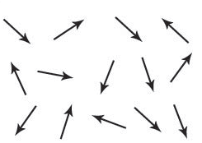
1. Paramagnetic: When electron spins in the atoms are ordered randomly as shown below, then the material is said to be paramagnetic. This is not the lowest energy configuration but it is the most chaotic (maximum entropy). There is no net magnetic moment.

2. Ferromagnetic: When the spins are aligned in a particular direction. There is a net magnetic moment.

3. Anti - Ferromagnetic: There are two types –

3.1 Equal: The spins are equal and cancel each other out. Therefore, there is no net magnetic moment.

3.2 Unequal: The spins are unequal and thus there is a net magnetic moment.

